**DAILY ONLINE ACTIVITIES SUMMARY**

|  |  |  |  |  |  |  |  |  |
| --- | --- | --- | --- | --- | --- | --- | --- | --- |
| **Date:** | **27/05/202** | | | | | **Name:** | **Anjali Manohar Prabhu** | |
| **Sem & Sec** | **4th Sem Section - ‘A’** | | | | | **USN:** | **4AL18CS007** | |
| **Online Test Summary** | | | | | | | | |
| **Subject** | | **Microcontroller Embedded System** | | | | | | |
| **Max. Marks** | | **20** | | **Score** | | | **18** | |
| **Certification Course Summary** | | | | | | | | |
| **Course** | **Lambda function** | | | | | | | |
| **Certificate Provider** | | | 1. **Great Learning Academy** | | **Duration** | | | **2.5hrs** |
| **Coding Challenges** | | | | | | | | |
| **Problem Statement: 1.** In Bubble sort, each pass consists of comparison each element in the file with its successor (i.e. x[i] with x[i+1]) and interchanging two elements if they are not in the proper order. The array may be sorted in any pass. If the array is sorted, then remaining passes should be skipped off.Write a C Program to sort an array of integers in ascending order and display the sorted array and Number of passes performed for sorting. | | | | | | | | |
| **Status: Completed** | | | | | | | | |
| **Uploaded the report in Github** | | | | | **YES** | | | |
| **If yes Repository name** | | | | | [**https://github.com/vinisharen/lockdown-coding**](https://github.com/vinisharen/lockdown-coding) | | | |
| **Uploaded the report in slack** | | | | | **NO** | | | |

Online Test Details: MES online test was conducted on date 28/05/2020 from 11:30 to 12:30. There were 20 question in total where each question consist of 1 mark, and the score I got is 18/20

SNAPSHOT: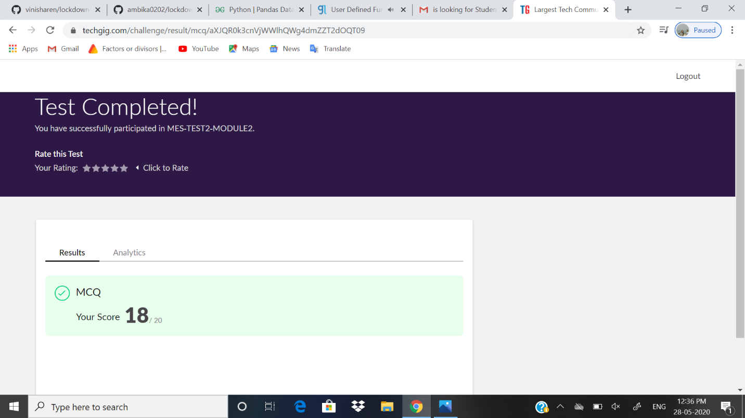

Certification Course Details: A lambda function is a small anonymous function.

A lambda function can take any number of arguments, but can only have one expression.

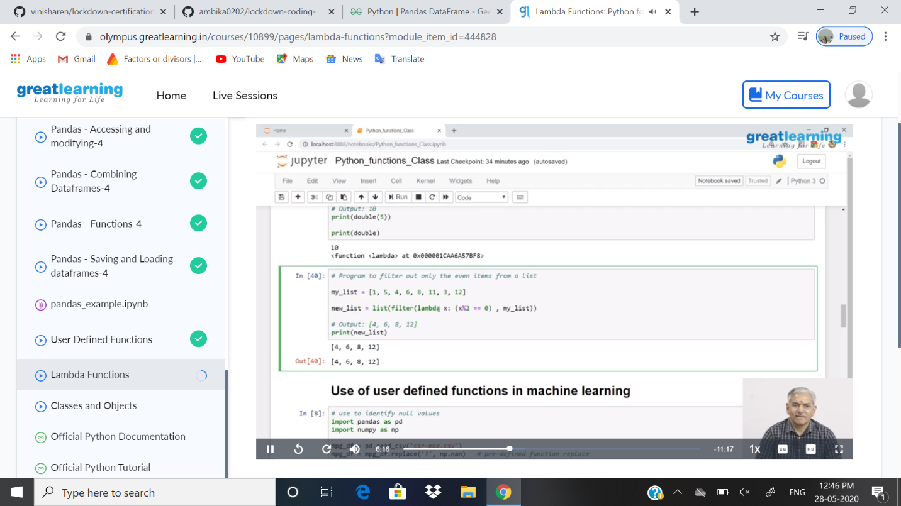

ONLINE CODING DETAILS:

PROBLEM 1: In Bubble sort, each pass consists of comparison each element in the file with its successor (i.e. x[i] with x[i+1]) and interchanging two elements if they are not in the proper order. The array may be sorted in any pass. If the array is sorted, then remaining passes should be skipped off.Write a C Program to sort an array of integers in ascending order and display the sorted array and Number of passes performed for sorting.

SNAPSHOT: